2
Conceptualizing a Borderland Approach to Kashmir

This chapter examines what is commonly referred to as the borderland in the Kashmir context and the epistemological consequences of this conceptualization. It focuses on the border spaces on both sides of the LoC and the conditions for political life there. Borderlands have been broadly defined as zones located on both sides of an international border (the edge) where the social dynamics are largely affected by the existence of this border, which regulates interactions between the two sides. Borders are institutions; they are the result of multiple activities of government and thus people’s interactions have to be considered within the constraints of these institutions. As institutions, they produce norms that regulate social actions within a specific space, even in contexts where borders are contested—which brings up the question of enforcement. Although borders are relatively persistent and stable over time, the norms that regulate them are continuously challenged from outside (i.e., by grassroot-level movements) or from within the state, leading to the border’s transformation. The border creates the borderland, in which the rupture caused by the border is ‘stitched together’ again through new societal arrangements and processes.

The borderland
Borderlands have commonly been examined through the lens of the state’s periphery: they are considered to have evolved from a process of territorialization in which the areas known as borderlands end up on the edges of power centres. This spatial perspective implies an epistemology of the study of borderlands as peripheries, based on the pre-eminence of the nation-state as a normative category. Consequently, this perspective has considered the histories and social processes of these border zones within the frame of the state territorial container. Van Schendel, in his work on the Bengal borderland, proposes a shift in this perspective: to take borderlands themselves as the units of analysis, if only as a ‘powerful corrective to the current territorialization and state-centricity of the social imagination.’ This shift implies, among others, highlighting social processes taking place in these territories by giving them centrality—a scholarly priority that helps rescale wider social phenomena but at the same time invites thorough theoretical reflection. This does not mean that we should take territorial borderlands as more or less bounded centres per se (as specific entities), but that we should instead scrutinize the bordering processes in these territories and how the affected cope with them, in order to explain the spatial politics at work in the construction of difference.
Borderlands have also been investigated as blurred zones in legal-constitutional terms, for their social diversity, and in relation to multiple spatial interactions. A political science approach assumes that the study of borderlands involves questioning the spatial power hierarchies that shape the interpretation of international realities, particularly in relation to the study of conflicts and the predominance of the state over other forms of the spatial organization of political life. It also implies breaking down how conflict is manifested in these territories, in the sense that conflict is usually not pervasive and equally distributed across the society. As blurred zones, borderlands are considered ‘anomalies’ with regard to their failure to fit into the spatial hierarchies associated with methodological nationalism. This is because of the difficulty that nationalism experiences in the handling of social diversity and its legitimation of violence in border zones on behalf of state-making processes. For these reasons, the study of borderlands has to operate within the paradox of their condition as spaces without a right to exist as political entities themselves, although international processes cannot be understood without the existence of these spaces.
Since borderlands are not only located within but also born out of a territorialization process, this implies taking into account the nation-state building that has produced a degree of differentiation from an ‘other’. Hence borderlands ultimately constitute instances of or ‘contexts’ for spatial transformation where the resulting interactions can be read as a process of ‘becoming’ rather than of ‘being.’ Looking at the map of Kashmir’s disputed territories, the first image that catches one’s attention is that of encirclement—a territory almost completely squeezed between international borders, some demarcated, others disputed. But the map also demonstrates ruptures through the compartmentalization of the divided territories. The disputed LoC separating India-controlled and Pakistan-controlled Kashmir has also divided the Pakistan-controlled AJK and Gilgit-Baltistan, not only physically (there is no direct communication link between the two regions), but also administratively. Azad Kashmir and Gilgit-Baltistan have a different constitutional status and are not integrated in Pakistan. Further fragmentation can also be seen in India’s claims to the Aksai Chin (under China) and to the border territories ceded to China in the Sino-Pakistan Agreement of 1963, all of which were previously part of the princely state. People in the Kashmir Valley claim the centrality of the Valley as part of the entire Kashmir region (the formerly princely state) in terms of a connecting zone, not only to India and Pakistan through existing land routes, but also to China in the memories of trade caravans, Tajikistan through renewed religious exchanges, and even Afghanistan in the connecting possibilities of the Wakhan Corridor. From time to time the Pakistani press publishes articles in favour of the connection of northern Pakistan with Central Asia through Wakhan, although this has not happened. Hence, despite the context of encirclement and fragmentation there are continuing demands for interconnectedness that shape an understanding of the region based on the Kashmir Valley’s centrality and proximity to a number of other places.
The encirclement of Kashmir is manifested in the limited (or sometimes non-existent) movement across borders and accentuated by the generally hostile relations between the nation-states, most notably India and Pakistan. The unsettled status of the LoC and the disputed Sino-Indian border exacerbate the problem of insecurity because there is a lack of information about what is happening at the border. This situation renders the entire area prone to conspiracy theories. For example, Hermann Kreutzmann has addressed events in Gilgit-Baltistan in detail, concluding, ‘it becomes obvious that outside interests and sponsorships are stimulating a conﬂict and battle for stakes in Gilgit-Baltistan’. Similar views are shared by Nooshin Ali concerning the issue of sectarian violence and development in the region within the context of the so-called War on Terror.
In 2012, for example, several Indian and international newspapers, including The New York Times, reported on the suspicious large presence of Chinese soldiers in Gilgit-Baltistan—news that could easily have been questioned if someone had bothered to travel to the area or consult an independent local source. The information was false: the relatively few Chinese workers employed on the widening of the Karakoram highway (KKH), whom I first saw in August 2009, were mostly escorted by Pakistani police, and this did not change in the following years. The intentions of propagating such false news have not been disclosed, but this shows the state of the security paranoia over events in the area. Security in the Kashmir borderland is not only about managing the current context of uncertainty, but also about preventing transformations that are considered undesirable from the state security’s point of view. Conspiracies still occur where there is a lack of normal flow of information in the era of Google Earth.
Adding to, or perhaps precisely because of, the amount of conspiracies in the area, the Kashmir borderland is wrapped in a halo of mysticism to the extent that India and Pakistan tacitly agree that the actual division (the LoC) is not represented on official maps. Indeed, the representation of the disputed area is subject to controversies in both India and Pakistan. It is not uncommon for Pakistani maps to show the whole of Kashmir (including the parts under Indian control) as belonging to Pakistan or disputed, while Indian maps invariably depict Gilgit-Baltistan and AJK as Indian areas. The pupils of one school in Kargil that I visited in 2013 were learning from maps that the border was distant, and that the whole of Gilgit-Baltistan was part of India, despite knowing from their daily life experiences that the LoC was only some 10 km away. In Baltistan on the Pakistani side, a teacher involved in teacher training explained to me that students in public schools followed the curriculum of the Punjab Textbook Board, so they would not learn about local geography and culture. It seems that those most affected by the conflict are not allowed to know about the intricacies of what is at stake.
In May 2011 The Economist published an article about India and Pakistan’s rivalry in Kashmir, showing a map in which the disputed area was divided between the two countries. In India, this map was censored by covering it with a blank sticker. However, the magazine’s cover had a cartoon depicting the border, under the title ‘The world’s most dangerous border’ (Image 2.1), but this was left untouched. The censoring shows how important maps, unlike a cartoon depiction showing the same space, are for depicting understandings of reality that are considered sacred, as if they were depicting a sacred space. The same idea can be seen in the reluctance to represent the fracture (the LoC). Instead of acknowledging the actual division on the ground, this non-representation and deliberate confusion helps to sustain the conspiracy-prone character of the Kashmir borderland, a world hot-spot in the sense that the situation may suddenly turn worse at any time. The mystical character of the region encompasses not only the LoC but also the surrounding areas, making these territories into places that are devoid of empirical and rational knowledge.
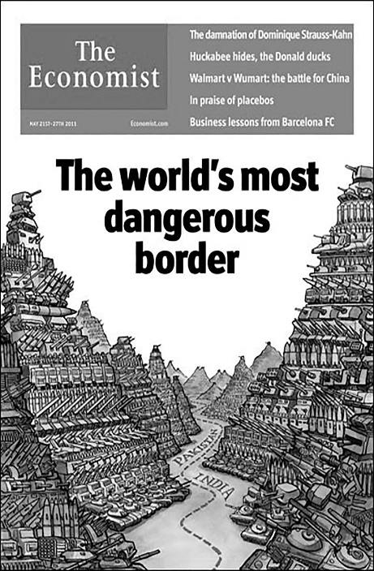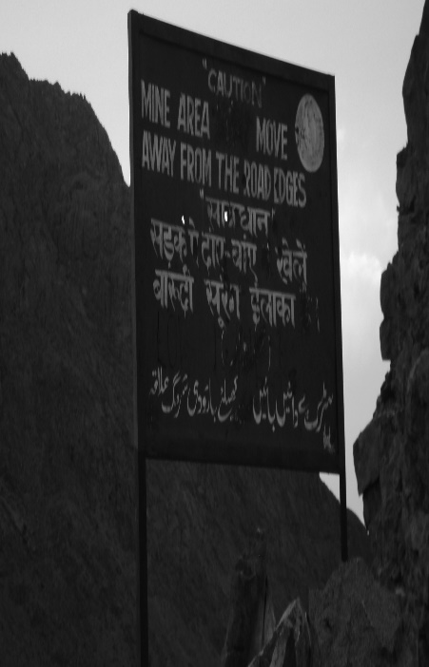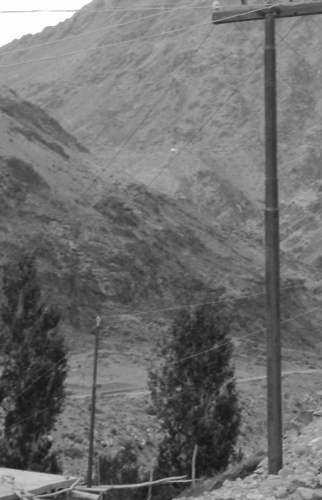
Image 2.1: Cover of The Economist, 9 May 2011. Image 2.2: Border area on the Indian side, Kargil. Image 2.3: Border area in Kargil, showing Reproduced with permission Photograph by Antía Mato Bouzas part of the Kargil–Skardu road. The shrine of Sher Ali is located at the rear on the top of the hill and Brolmo village is located below it.
Photograph by Antía Mato Bouzas

Observation of the LoC on the ground, from a nearby area, shows a different picture. On the one hand, the border character of the LoC is strongly present in the landscape: the threatening militarized aspect can be seen from the large army camps that are spread everywhere, including very remote areas, and also in the way the military interferes in civilian life at the border. On the other hand, an element of empathy for the ‘other’ exists at the border alongside an irremediable acceptance of the state of things. At the time of my research visit in May 2012, a lone soldier (a young Assamese man) stationed on the road to India’s last village in the district of Kargil, located around 3 km before no-man’s land, had no particular animosity towards ‘the Pakistanis’, he said, and was instead focused on his role of controlling and protecting his position (Image 2.2). Similarly, an aged woman, a farmer from a village on the Indian side from where it is possible to see the impermanently inhabited village of Brolmo some 6–7 km away on the Pakistani side, spoke of her interest in the whereabouts of those living in Brolmo because ‘they were the same’. Despite describing how happy she was in India because her husband and son worked in the local administration, she was still worried about her neighbours on the other side of the LoC. The village was within sight (Image 2.3) and she could see that its inhabitants sometimes visited the nearby shrine of Sher Ali or tended their fields during the sowing and harvesting seasons. Moreover, Indian soldiers stationed nearby shared information with those on the Indian side about their neighbours across the LoC. Observing the border at the border, the threatening image of the army fails to deter instances of humanity emerging at the local level. At the border it seems clear that the sense of insecurity emerges from elsewhere and that measures to tackle this insecurity are imposed upon these border areas.
Governments sitting in distant places—such as New Delhi, Islamabad, and even Washington—alongside media, and also sections of academia represent the border space as a security domain. Such representations of space are manifested locally as a sort of irony, as the impossibility of these places on both sides of the LoC of being or becoming something different. This can be exemplified in the road that once connected Kargil and Skardu: while its closure prevents the communication of those living on both sides who want to maintain ties, it continues to allow the circulation of jeeps from the international monitoring team of the UNMOGIP ceasefire observers. Created by the United Nations Security Council’s resolution 47 (1948) to monitor the ceasefire, the UNMOGIP is partially a relic of the past, without legal relevance once the UN ceased to be involved in the dispute, but one that keeps highlighting the ‘international dimension’ of these territories. The image of UNMOGIP jeeps travelling along a road from which those inhabiting the border areas are banned shows the contrast between the representation of space by international actors and the experience of those who are represented by others and prevented from speaking for themselves.
Those living on both sides of the LoC are unable to meet across the nearby border; the few who can afford it manage to travel (after lengthy bureaucratic processes) to the other side via international flights or by the land route by crossing the international India–Pakistan border at Wagah/Attari. The border suppresses the idea of ‘local’ or ‘domestic’ space and strengthens the international dimension as a space of separation. People need to go to Delhi, Islamabad, Amritsar, or Lahore to make their way to locations on the other side of the LoC that could easily be reached within 2–3 hours by road, and this movement is mediated and regulated by bureaucrats living in those distant cities. The exclusion of the ‘local’ and the ‘domestic’ in the provision of security and the embracement of the international—which can only occur through third-party mediation instead of a dialogue between the concerned parties—acts as a reminder of the post-colonial condition of these territories.

Border roads: the contours of making state space
Borders completely permeate life in the Kashmir divided territories. In the summers of 2010, 2011, and 2012, I travelled the route from Srinagar to Leh three times. During my first visit in May 2010, I recall the presence of Central Reserve Police Force (CRPF) soldiers stationed at intervals along the route from Srinagar to the vicinity of Sonamarg. At the time, the situation in the Kashmir Valley was very tense because of the increasing force of the stone-pelting movement in Srinagar and other major towns. Teenage boys, emulating the Palestinian Intifada, were venting their frustration by attacking the Indian paramilitary with stones after Friday prayers and by using the tactics of street guerrillas in their escape through the narrow alleys and courtyards of the Kashmiri old towns’ typical urban architecture. The revolt was a response to several incidents in the winter and spring of that year in which Kashmiri teenage boys were killed by the CRPF and the Border Security Force (BSF). The Indian authorities were preoccupied with the situation and the governor N.N. Vohra had pressured influential Kashmiris to denounce the stone-pelting movement. The city of Srinagar, itself militarized and temporarily divided by checkpoints and barbed wire during curfews, symbolizes the pervasiveness of fragmentation in the region.
While travelling by bus from Srinagar to Kargil and observing the continued presence of soldiers stationed along the roadside, it was difficult to figure out whether the paramilitary were deployed to protect and control the road, and the terrain in general, from a possible attack, or to monitor the nearby rural areas and people. At some points, paramilitary personnel of the CRPF were posted in front of a row of shops, almost unnoticed by the passers-by, while in other cases, they were standing next to a tree in the countryside, or posted under a rock to cope with the inconveniences of a rainy day. One sight caught my attention before reaching the town of Ganderbal, when the bus made a short stop owing to the traffic. Through the window I saw a soldier posted under a tree close to a few houses in the countryside. A middle-aged woman was passing near him with a cow, probably taking it to the fields. How should I interpret this situation? Was she intimidated by his presence? It was remarkable how everyday life could carry on in a sparsely populated hamlet with an armed soldier overseeing the inhabitants’ everyday activities—even if he was not posted there for that purpose.
This picture draws our attention to how borders as security markers are inscribed on people’s bodies; they embody a specific rationality that implies a disciplinary character, in the Foucauldian sense. Borders are ‘dispositives’, following Giorgio Agamben’s definition: ‘that in which, and through which, one realizes a pure activity of government devoid of any function in the being.’ Borders penetrate the sphere of intimacy, and through this contact new sets of power relations are created. It is not rare in the Kashmir Valley to hear stories about the atmosphere of constant distrust because of the presence of ‘informants’ and ‘collaborators’ of the police and military, as well as a preoccupation with issues of morality and domination in cases of local women involved in love affairs with security forces personnel. These stories are told to explain the ‘dehumanized’ context created by the conflict, in which it is no longer possible to distinguish between ‘friends’ and ‘foes,’ ‘we’ and ‘they’, and where people (even within family networks) cannot trust each other. They also provide an understanding of the difficulty of clearly differentiating between parties in the conflict, since certain groups are seen as having second thoughts or being ‘Indian’ or ‘Pakistani’ agents and thus being unreliable. Part of this reality has been portrayed in the popular Bollywood film Haider, a free adaptation of Hamlet to the Kashmir context in which the family drama of treachery is extended to the society in the Kashmir Valley. Examining the border on the ground, it is possible to conclude that, more than differentiating between ‘we’ and ‘they’ as border studies scholars point out, borders destroy the basic sense of ‘togetherness’ or ‘bondness’—thus making any ‘we’ or ‘they’ no longer workable as a uniform category. This can be seen in conflict zones such as Kashmir, but also in Chechnya.
Continuing with the journey, close to Sonamarg, Hindu pilgrims from Jammu and other parts of India confront the last leg of the Amarnath Yatra (Image 2.4). Sonamarg is also a popular tourist spot owing to its natural beauty and proximity to Srinagar. The importance of these spaces is reflected on the landscape. Suddenly, advertisements for vegetarian restaurants and hotels with Hindu names replace the signs in Urdu and Muslim names that had dominated the earlier parts of the route. Restaurants and hotels are there to cater to pilgrims’ and mainly Hindu tourists’ needs. Many of their owners are from Jammu and move in the summer season to this area to earn a living. This activity at this point of the road coincides with the presence of signs at different points of the road—more numerous after the town of Ganderbal in 2012 than in May 2010—containing warnings for the pilgrims and indicating that the army was there to protect them. Pilgrims to Amarnath have been attacked during periods of widespread violence in the Valley, mainly by groups with a base in Pakistan, such as in the attack in July 2017 by Lashkar-e-Taiba. Kashmiri nationalists have either been indifferent to these attacks or have called for pilgrims to be treated with respect and hospitality. Even militant groups rooted in the Valley—that is, Kashmiri militants such as Hizbul Mujahideen—have publicly stated that pilgrims are not their targets. The pilgrimage is also a source of income for local Muslims, who benefit from the event.
These facts notwithstanding, signs on the roadside at the time of my research visit evoked a climate of fear and insecurity. Slogans such as ‘Have a safe Amarnath Yatra’ and ‘We are here to ensure your protection’ indicated that pilgrims were taking a risk and needed the army’s protection. They also illustrated how the pilgrimage is being used politically, as noted by Ian Reader, who points out that ‘Hindu nationalists organizations have encouraged Hindus to participate in the Amarnath pilgrimage as a statement of Hindu pride and in order to reinforce Indian claims to the region.’ Reader also describes how the Indian Army has been deployed during the pilgrimage season for logistical support. As with the representation of the LoC as the ‘world’s most dangerous border’, the security discourse around Amarnath develops somewhere else to advise the traveller of the road’s dangers, but still invites him/her to continue the journey under the premise of receiving the army’s protection. This is because, without the pilgrims and the ‘Hindu space’ created in Kashmir’s ‘Muslim’ heartland, it is not possible to interfere with and make claims to the territory. In other words, the pilgrimage can be understood as a form of settlement activity that invites further colonization and securitization of this territory.
The dominant security discourse dictates the mechanisms to be implemented depending on how the problem is defined. The border is dangerous and needs to be protected (and militarized); while the pilgrimage may be risky, its continuity should be ensured. The mechanisms used to tackle the security problem have one aim: to transform the local space. They constitute a form of border making in the sense that when an issue is identified as pertaining to the security domain, several material and non-material interventions are carried out to isolate it and deal with it in a differentiated manner. For example, government (of India and Kashmir) support for Amarnath and other tourist sites (e.g., Tossamaidan) contrasts with the ban (or severe control) of Muslim religious processions and gatherings, such as the Shia festival of Muharram, which have been prohibited since 1990 in many places in the Kashmir Valley. The arguments in favour of supporting and protecting Amarnath and tourism in Kashmir, despite the fact that it is a conflict zone, are part of a strategy of transforming the Kashmir space, underlining its ‘Hindu’ relevance, and portraying the region as ‘peaceful’. The celebration of Muharram challenges that representation because Muslims do not need protection (from the Indian army), and their religious activities underline the Islamic character of the Kashmir space as opposed to the Indian secular nation. From the state’s perspective, then, the celebration of Muharram is a potential source of conflict.
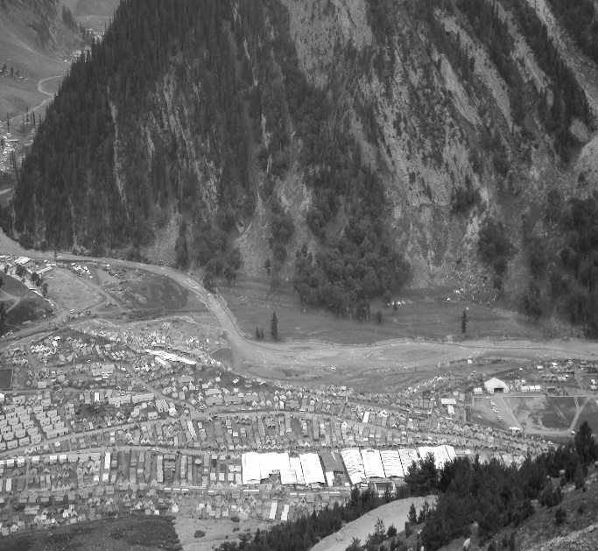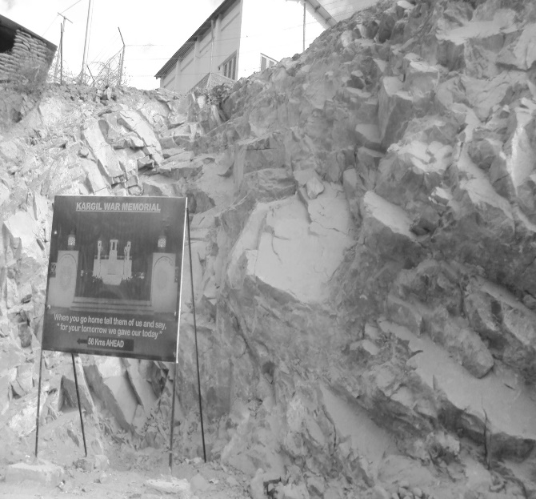
Image 2.4: Amarnath, camp area for the pilgrims, located in a military camp. Image 2.5: Sign about the Kargil War memorial.
Photograph by Antía Mato Bouzas Photograph by Antía Mato Bouzas
After leaving Sonamarg and heading towards the little-populated area that extends from Dras to Kargil, the military presence in scattered camps announces the proximity of the LoC and the memories of the Kargil War fought in the late spring–summer of 1999. In fact, the sites of the fighting (including an open-air war memorial museum) have been turned into popular attractions, mostly for Indian tourists interested in knowing about the remote confines of the nation (Image 2.5). At the time of the fighting, news of the Kargil War was transmitted to the Indian audience amid a climate of triumphant nationalism. The conflict drew the attention of the media to these relatively little known and unguarded ‘edges’ of the nation through the enthusiastic narratives of India’s victory by journalists who were able to access the area, which I listened to as a university student in Delhi. The episode symbolized the establishment of the LoC, since it brought attention to the edges (i.e., the control of mountain peaks in the terrain) and marked a new approach towards the border populations. The latter has been analysed in great detail by Bhan in her study of the minority Brokpa villages living close to the LoC. Based on anthropological fieldwork, she demonstrates how development programs following the Kargil War were used as an instrument to co-opt the otherwise untrustworthy border populations. Adding to development projects, the post-war boosting of Indian tourism to the area has also constituted a strategy of inscribing Kargil as indisputably Indian.
After leaving Kargil and heading towards Leh, gradually getting further from the LoC, the pervasive India military presence continues, but this time it is there to counter a different enemy: China.
Travelling along the road from Srinagar to Leh, part of which runs close to the LoC, it is possible to distinguish the borderland, as indicated by the social diversity of these territories and the attempts to control that diversity and transform it into state space. From the road, this appropriation becomes visible through the military control and the transformation of sites and places into valuable symbols for the nation. The borderland emerges out of a continuous historical process that implies ‘conflict and accommodation’, as Zutshi has aptly described it, but one which, in the modern version of the post-colonial state, denies borderlanders the possibility of resistance. While this process follows the logic that all space must be administered and occupied, it also implies an imposition and has hierarchical connotations. Within this logic, the borderland is a space to be vanished: as James Scott reminds us regarding Zomia (which is a borderland), it belongs to a period in ‘which such peripheries are shrunken and beleaguered by the expansion of state power’ to ultimately be rendered folkloric remnants. Nowhere are these advances of the state more visible than in the Kashmir borderland, where those who seek to oppose the state can only act through the language of the state (claiming a state for themselves such as the Kashmiris from the Kashmir Valley), and other minority groups in the Kashmir Valley and Ladakh (and Gilgit-Baltistan on the Pakistani side) can only become tribes or valuable symbols of sustaining the national diversity.
Travelling along the border roads of Kashmir’s disputed territories allows the observation of ongoing dynamics in the border spaces that denote attempts to bring the territories under state control through militarization as well as by changing the character of the area through various interventions, such as the building of infrastructure and the boosting of (Hindu) religious tourism. The transformation of space is an essential activity carried out through physical interventions that can be empirically identified, but at the same time they are framed publicly through a discourse about the insecurity of the area. This security–insecurity paradox—that the Kashmir borderland is dangerous, but militarization brings security; that pilgrims should proceed on their journey, but need to be protected—determines both the uncertainty and the modes of control of the borderland.

Violence, social diversity, and fragmentation
Borderlands have historically been described as zones with the potential to realize the anarchic utopia of freedom, but this rather idealistic vision ignores the historical trajectory of violence and repression by different powers seeking to dominate these areas. This historical trajectory has left its imprint in the social and political organization of the border territories that we see today. The British colonial policy on the frontier, which was characterized by brutality and indirect control, continued after the creation of the states of India and Pakistan in 1947. Indeed, traces of these strategies of domination can be still found in the ongoing conflicts in Balochistan, the Federally Administered Tribal Areas (FATA), Kashmir’s disputed territories, and India’s north-eastern states. While the case of Balochistan involves a strong economic component—in the sense that the conflict impinges on state control of an area rich in mineral resources—the other conflicts revolve around the control of the edges of the nation, and are also about their condition as launching pads for border-based foreign politics, as highlighted in the case of Pakistan’s involvement in the FATA and AJK.
Moreover, exceptional legal instruments such as the colonial Frontier Crimes Regulation (FRC) of 1901 have been in force in parts of Balochistan in the past and in Gilgit-Baltistan until 1974, and they were still the main legal instrument, though amended in 2011, overlooking affairs in FATA until they were removed in 2018. FCR involved the codification of customary law, giving power to already-established traditional hierarchical and patriarchal structures, while also appointing an agent of the central government to rule the area. This mechanism has prevented the development of institutions and democratization processes. On a different level, the AFSPA, which sustains militarization by giving extra powers of detention, extrajudicial killings, and so on, in Kashmir and parts of the north-eastern states of India has origins in a British India ordinance of 1942—ironically implemented to quell the nationalist Quit Indian Movement—which was later incorporated into the legislation of independent India. The AFSPA has been in force since 1958 in the state of Manipur and since 1990 in the Kashmir Valley. It is ironic that a legal instrument created by the colonial power against those fighting for India’s independence has been preserved by the Indian leadership to deny that very right of independence to other groups within the nation. Moreover, the AFSPA, as the Indian lawyer A.G. Noorani points out, has also perpetuated the dominance of interests of the army over civilian rule, thus prolonging authoritarianism.
While people in the Kashmir disputed territories have been nominally integrated as nationals of the state, they have been excluded from the democratic processes that developed in the main territories of India and Pakistan. Indeed, their citizenship status is uncertain. The border territories have been ‘kept apart’ through exceptional legal-administrative arrangements that have prevented the development of a democratic culture and instead favoured authoritarianism. Thus the image of the anarchist utopia that has sometimes been used to describe the pluralism and relative egalitarianism that characterizes some of the world’s borderlands has not materialized in Kashmir. Despite the borderlands’ potential to provide insights that can lead to the articulation of more inclusive political spaces, there is also a drive to suppress what is left of this diversity in order to deny the possibility of the borderland’s right to exist. Although there are instances of confrontation, the Kashmir border territories still retain a degree of coexistence which is reflected in their human and cultural diversity based on past interactions. The establishment of the LoC has abruptly put an end to such interactions, but research carried out in the border areas shows their continuing importance through memory, the revival of cultural expressions, and the re-enactment of family ties across the LoC. These connectivities underline the character of border towns as crossroads of influences and these connectivities serve as a form of resistance against the marginalization of these locations through their confinement within the borders of state, well before the ‘national’ made its appearance. Indeed, it is striking that the dialogue process between India and Pakistan, initiated in 2004 to solve the Kashmir dispute, revolves around ‘opening’ and increasing the ‘flexibility’ of the LoC based on the, supposedly, rediscovered ‘cosmopolitanism’ of economic globalization processes.
In fact, it is the social diversity of the borderland—the need for translation as a multilingual place—and the impossibility that it can be defined in existing political terms, that paves the way for alternative forms of political life. This has been described by Etienne Balibar in his understanding of a borderland model for Europe as a ‘political space imagined in terms of overlapping open regions.’ Preoccupied with addressing the multiple belonging of migrant communities and their descendants in Europe through the principle of egalibertè (‘equaliberty’), his model rests on a critique of the continuous reproduction of state space despite transformations in the society that cause new forms of exclusion and inequality. He has also alluded to the Palestine–Israel conflict to demonstrate the need for post-national politics to understand the Palestinian cause, because solutions cannot be imposed from outside and ‘Something has to be invented’. These reflections echo the situation of the Kashmir disputed territories in the sense that the borderland (i.e., the existing social and cultural diversity) is rapidly vanishing because of the advancement of the state—through violence and authoritarian politics—but on the other hand neither India nor Pakistan can ignore the plight of the Kashmiris, or of those residing in Gilgit-Baltistan and in AJK. In other words, the political articulation of social diversity in terms of equality and freedom in the Kashmir context allows for a better understanding of the problem.
The argument of this book draws on the fact that the Kashmir borderland as a context for spatial transformation already exists, but is fast disappearing because of the lack of ‘invention’ of any formula to politically articulate such diversity. By ‘advancement of the state’, I mean not only the institutionalization, but also the impossibility of thinking in terms of more inclusive categories instead of caging peoples into various identities and national adherences. Borderland thinking becomes an opportunity to revisit the Kashmir dispute and disentangle its epistemological tropes from methodological nationalism. Julian Minghi has worked on Italian borderlands and focused on the transformation of former conflict borders into zones of cooperation facilitated by institutional recognition of their diversity. His understanding of borderlands is certainly normative—from conflict to cooperation—and confined to the European experience. In parts of the world that are marked by the experience of colonialism, state-sanctioned immobility across borders such as that exemplified by the case of Kashmir reflects the post-colonial state’s limited capacity to institutionally influence processes of ‘othering’. Indeed, it is generally expected that ‘othering’ processes will occur just by keeping the border closed. This fortification of the edges is also a sign of fear and weakness (i.e., the loss or lack of sovereign power), which manifests as a violent process with dramatic consequences for the local populations affected. The Kashmir borderland is being controlled and monitored—and thereby disciplined—by the armies and the political-bureaucratic establishments of India and Pakistan. It is being appropriated by them, the result of a struggle to maintain control over an area that has been defined as strategically valuable, and this is carried out through the division and compartmentalization of the borderland territory.
Processes of ‘othering’ concern differentiation not only from those across the border but also, and mostly, from those in the territory within, through the control of people and transformation of the border space. Walling—the proliferation of fortresses everywhere—is a representation of emerging insecurity/ies but also the ‘act’ under which other security measures are implemented to continue the old formula of ‘divide and rule’. For example, Kashmiri nationalist groups have been blamed and singled out for not being able to engage in a dialogue during the 1990s conflict with other groups within and beyond the Kashmir Valley, such as Kashmiri Pandits and Buddhists from Ladakh or Jammu. However, this view neglects the work done by other actors, such as Hindu nationalist groups, in particular the Sangh Parivar, to successfully exploit the sentiments of alienation from the Kashmir movement held by Ladakhi Buddhists and Hindus in Jammu (including the Pandit exiles). The Sangh Parivar has from time to time insisted on the trifurcation of the state—that is, the administrative separation of Kashmir, Jammu, and Ladakh. Moreover, Kashmiri political actors, such as the dominant NC party, have also been responsible for using identity politics by demanding more autonomy and an internal administrative reorganization of the Jammu and Kashmir state along ethnic-religious lines. Although the use of identity politics by the NC was largely an expression of self-affirmation meant to gain regional support in the tug-of-war with the governments of New Delhi, it also inadvertently created divisions in society in respect to minorities.
Furthermore, the dynamics of conflict, displacement, victimhood, and lack of trust among people has contributed to creating a context in which dialogue with others has become almost impossible. This context of internal fragmentation in Indian Kashmir (which is also present on the Pakistani side), for which a single group cannot be blamed, underlines the effects produced by the LoC on the ‘domestic’ spaces created on both sides (the state of Jammu and Kashmir, AJK and Gilgit Baltistan) rather than across them. In other words, the security mechanisms to maintain and monitor the LoC destroy any possibility of a community—a ‘we’—emerging in the area, while also being ineffective in differentiating an ‘other’ across the border. Returning to the example of Kashmiri nationalists’ inability to engage in dialogue with other groups, such as Kashmiri Pandits or Ladakhi Buddhists, it can be argued that these groups are not equal interlocutors. They have gone through different experiences of conflict and their views about each other have been mediated by both the political circumstances and specific actors, such as security agencies.
Yet, despite the prevailing process of compartmentalization and fragmentation, some groups that are divided across the LoC are seeking to challenge this context. This is the case with the Baltis separated between Baltistan and the border areas of Ladakh (mainly in the Kargil subdistrict) on the Indian side, and the Paharis living in the mountain areas adjacent to the Kashmir Valley and stretching across the border areas of AJK. Although cross-border immobility has imposed separation—setting aside the fact that occasional interactions such as ‘illegal’ crossings have occurred—families and cultural groups have restored relationships with each other through meetings in third countries or marriages (in the case of Paharis), and, in a few cases, have gone through lengthy processes to visit each other in their respective countries. These exchanges, though limited, show that despite the conflict and the reality of physical separation, interactions have not stopped, and they also provide evidence of the social dynamism of the border space. Borders are established to exert violence (territoriality) and are themselves the product of violence, but they are unable to completely fulfil the purposes for which they have been created, such as the control of people, the creation of a differentiated ‘other’, and the distinction of a separated national-international domain.

The Kashmir borderland as a distinct political space
At the beginning of this chapter I highlighted the fact that borderlands are characterized by continuous processes in the making, the result of interactions and negotiations, and therefore without end. This shows that the borderland has its own temporality that does not necessarily correspond with that of the state. Neither the state of Jammu and Kashmir in India nor AJK and Gilgit-Baltistan in Pakistan qualify as state spaces, if the definition of the state as a functioning institutional framework includes a degree of participation and attachment of the people to the polis or implies a certain domestic territorial administrative harmonization with various degrees of autonomy. Moreover, the symbolic power of the state through the display of flags, self-advertisement, ceremonies and so forth in the public space occurs behind the scenes in all of these territories because only a restricted group of state authorities and people (and not the population at large) participate in them. This is partly because such power is contested, as suggested in the boycott of Indian symbols in political and cultural events in the Kashmir Valley, but also because it proves to be loose and unstable, though repressive, in a context of relative weakness such as AJK and Gilgit-Baltistan. In the Kashmir Valley Indian symbolism is certainly boycotted, but the state continues to exercise its visibility through militarization, the occupation of territory, and the presence of slogans referencing ‘nationhood’ and ‘security’. Meanwhile in AJK, Pakistani flags and other symbols seem to be reduced to those relating to the army that protects the borders in order to convey the idea that the region is self-governed and semi-independent, although in practice there is strong (state) control on the bureaucracy of this territory, the population in general, and, of course, dissident civilians.
Equally, the constitutional statuses of the state of Jammu and Kashmir, AJK, and Gilgit-Baltistan are, at least, ambivalent. Jammu and Kashmir is recognized as a state within the Indian Constitution of 1950, with special autonomy under Article 370 (through a constitutional order of 1954). This autonomy has been severely undermined by the Indian Government through legislative changes and constant interference in the democratic government of the state, including the change of chief ministers at will and the rigging of elections, which has provoked widespread discontent. The culmination of this situation is the military occupation of the Kashmir Valley since 1990. Electoral processes have happened regularly since 1996, but cases of rigging and forced participation (people in remote villages close to military areas are ‘persuaded’ to vote) indicate their lack of transparency. Moreover, Kashmir nationalist leaders have boycotted the elections, and those Kashmir-based parties that participate in them, such as the NC and the PDP, usually remark that elections are not for deciding the future of the region but rather for addressing the most immediate needs of the population. Hindu nationalist groups under the political umbrella of the Bharatiya Janata Party (BJP) have occasionally asked for the removal of the special autonomy granted to make Jammu and Kashmir under Article 370 so that it will become like any other Indian state. This demand has been a matter of debate after the arrival to power of the chauvinist government of Narendra Modi in 2014, but constitutionalists have given warnings about the risks of its implementation. Since Article 370 is the only one that legally binds Jammu and Kashmir to India, its removal could technically grant the territory independence.
A similar situation can be observed in Pakistani-controlled AJK and Gilgit-Baltistan. AJK also has an odd constitutional set-up: it is a sort of semi-independent state with its own constitution, but its defence, foreign affairs, and communications are controlled by Pakistan. The reason for this is that AJK is considered to be a territory for ‘exiled’ Kashmiris, and its government functions according to this premise, but its future has to be determined along with that of Indian Kashmir. This constitutional arrangement has nothing to do with the practice, however: the Pakistani establishment oversees all affairs in AJK, as I observed during a few interviews conducted with mid-range officers of the Azad Kashmir Government in Muzaffarabad in March 2010. Dissent concerning Pakistan’s interference in ‘domestic’ affairs was subtly expressed through cases regarding development projects such as the Neelum-Jhelum dam. Moreover, the Pakistani Government often argues that Azad Kashmir, unlike the Kashmir Valley, is not militarized (understood as the display of military and the paramilitary in the public space), but a more appropriate reading would be that in AJK the control of the population is tightly exercised by mainly men who do not necessarily wear army uniforms. At least in urban spaces, intelligence agents monitor the population in plainclothes and ride motorbikes to check what people do and say.
Gilgit-Baltistan has the most uncertain constitutional status of all the Kashmir divided territories, despite the fact that local bureaucrats there informally refer to it as a province of Pakistan. As mentioned above, the region was governed through a colonial form of administration until 1973, and gradually a regional administrative body was developed through executive orders by the successive Pakistani presidents (in charge) but this administrative body was given only very limited powers. The 2009 Gilgit-Baltistan Empowerment and Self-Governance Order equated some administrative figures such as the chief minister and institutions such as the Appellate Supreme Court with existing ones in the Pakistani provinces. The latest changes were introduced under the Gilgit-Baltistan Government Order 2018, which eliminated the Gilgit-Baltistan Council and reinforced the powers of the Chief Minister, among other modifications, but the order failed to address the most controversial issues. Local inhabitants question this legislation on the basis that they still cannot cast votes in the Pakistani general elections and, from a more everyday perspective, due to the lack of administrative and political transparency in the running of regional affairs—that is, the interference of intelligence agencies, curfews, and increasing sectarian violence and its orchestration. Gilgit-Baltistan poses an interesting case of nationalism in the Pakistani state-building process. While some groups in Pakistan were, and still are, at odds with Pakistani nationalism, such as in East Bengal (now Bangladesh) earlier and in Balochistan at present, a significant number in Gilgit-Baltistan would probably like to become Pakistani citizens. However, the Pakistani state is denying this possibility until the Kashmir dispute is solved. Pakistani officials believe that, in the event that a plebiscite is held (if that ever happens), local votes would count towards support for the whole of Kashmir becoming part of Pakistan. Such a view prompts the conclusion that those living in Gilgit-Baltistan are hostages in the dispute.
The extraordinary legal status of the state of Jammu and Kashmir, AJK, and Gilgit-Baltistan has created a context of uncertainty at many levels (legal, political, economic, and cultural) for a long period of time. But this ‘exceptional-legal condition’, which manifests differently in each of these places, does not mean a stalemate until a decision is made on the final territorial settlement, but rather provides the conditions in which the state can intervene to transform these border areas. In this sense, the state of legal exception does not preclude the existence of a sovereign power deciding about this legal state of exception, as understood in Carl Schmitt’s theory of exception, nor is it a legal void that has become the rule (in a landlocked territory or camp), as illustrated by Agamben. Sovereign authority over the Kashmir border territories is uncertain, or at least contested, and mobility is restricted, but not completely. Legal exception in the Kashmir borderland is about place, about the control and transformation of places, and not about the restoration (by the sovereign) to a previous ‘normal condition’ that never existed. The context of uncertainty allows specific forms of control and intervention (militarization, extralegal powers of the state, policies aimed at the transformation of the border landscape) similar to those pointed out by Agamben in the description of the camp as a sort of laboratory. However, these activities cannot be seen as the result of an intensification of sovereign power, but rather as attempts to establish sovereign power over places where sovereignty is absent or uncertain.
Interventions occur by violent means of dividing people (to create a context in which nobody can trust anyone else) and by non-violent forms of integration, such as making the borderlands economically dependent (through tourism and the building of infrastructures), and transforming the symbolic space (e.g., the Hindu pilgrimages in the Kashmir Valley). Non-violent means of integration are articulated on the basis of delivering good governance to these neglected and poorly administered territories. The latter is explicitly mentioned in the various legal and consultation documents that address the administration of these territories, such as the Gilgit-Baltistan Empowerment and Self-Government Order of 2009, the reports of the working groups of the Jammu & Kashmir Roundtable—created by the Indian Government in 2006 to address the concerns of the Kashmir Valley—which became public in May 2007, and the expert mission which created A New Compact with the people of Jammu & Kashmir. In these documents, ‘governance’ implies the transformation of the border areas by simultaneously opening and enclosing them within the ‘state space’. Furthermore, the ‘opening’ of the border in the context of India-Pakistan cross-LoC initiatives is meant to create a ‘normal border context’ in which various levels of social interactions can take place, as an attempt to transform the disputed character of these territories. The logic of governance reduces the political conflict to an issue of management. Thus whereas in the Gilgit-Baltistan order there is no reference to the constitutional status of the region, the latest report of the Indian interlocutors for Jammu and Kashmir suggests on page 2 that ‘Jammu and Kashmir should continue to function as a single entity within the Indian Union,’ despite the fact that they recommend the setting of (on page 3) a constitutional committee to revise the constitutional relation with the state, given its special autonomy. In other words, the report does not question the status of Jammu and Kashmir as part of the Indian state, which is the matter of contention by Kashmiri nationalists and by Pakistan. Similar views are expressed by the European Union and the USA when showing concern about the ‘dispute,’ such as in the recommendations given in the report of the European Parliament in May 2007, and in the US-Pakistan joint statement of 22 October 2015. The idea behind these comments is that the dispute can be ‘managed’ and contained under (state) control, bilaterally, as an issue between India and Pakistan.
Governance thus constitutes another way of controlling territory, another stage, after military solutions—such as the militarization of the Kashmir Valley and the attempts by Pakistan to capture it—which have proved unsuccessful. Maybe, as a number of authors have pointed out, the focus on governance indicates instances in which the sovereignty of the state is vanishing or rendered contingent, but, on the other hand, it also shows the state’s capacity to rescale and adapt to changing socio-economic conditions. However, the magnitude of the interventions into certain places can also be interpreted as the intensification of state’s sovereignty and evidences these tensions. This can be seen, for example, in Bhan’s writing about how counterinsurgency initiatives bring the military and Brokpa villages into closer relationships of interdependence and how development territorializes identities.
The power of the state appears to be disseminated within the borders in symbolic terms, but its coercive side is unequally distributed and concentrated in some locations (e.g., airports, checkpoints, military zones, and street curfews) and in the monitoring of bodies (inspections of cars, body checks, the need to provide information to people identified as working for the security agencies, the need for collaboration—paid or unpaid—as army porters, the limiting of civil and political rights). This context coexists with a climate of apparent economic normality, in the sense that normal economic activities among private individuals are not disrupted, although the state interferes by fostering dependence and dictating the pace and direction of such activities. Thus the state operates behind the scenes in the borderland, partly because its power has been challenged and resisted by the border inhabitants, and partly because this serves its strategy of converting the undefined condition of these borderlands into sovereign state spaces.

Conclusion
The territorialization processes in the Kashmir borderland reveal that the state is not in full control of these territories despite the attempts to bring them under state purview. These attempts do not imply the traditionally assumed automatic spread of state power—through conquest, in the classical sense, or institutionalization processes that embody governmentality as a new rationality, in the modern sense—over areas which are not yet under its control. By already having some degree of control over the edges, the aim of the post-colonial states of India and Pakistan is transformation of the space within for the purposes of domination. This is carried out by the exploitation of the exceptional-legal status of the borderland, which creates a context of uncertainty at several levels. This has been illustrated in the processes of appropriation and control of the border road between Srinagar and Kargil by the paramilitary and the posted signs with messages of protection for the Hindu pilgrims doing the Amarnath Yatra, which both welcome them and seek to make their presence necessary in that dangerous territory. The objective is to convert the area into a normal state space by eliminating conflict (through the military and police) while facilitating incorporation through symbolic and economic means (the political use of Hindu pilgrimages in a majority Muslim area and the economic dependence on tourism). At the border it can be observed that the security discourse on Kashmir is framed elsewhere: it is not based on the understandings and feelings of the people who live there, but instead imposed on the territory through various means—military, legal, economic, and so on.
Although borderlands emerge as a result of a history of multiple interactions that highlight human diversity and adaptation, but also conflict, territorialization processes acting on behalf of state spatiality follow a logic by which borderlands are deemed not to exist. This poses a paradox because a number of international processes—migration, smuggling, interethnic relations, and so on—cannot be conceived without the existence of borderlands. The existence of the Kashmir borderland, like other borderlands, revolves around a dual process of incorporation into state polities (India and Pakistan) through violence, and a process of exclusion through the denial of democratization. This being part of the state but not being on equal terms with people living in other state territories underlines the provisional character of borderlands in political terms—that is, borderlands exist but their political status cannot be recognized. Thus the definition of Kashmir as a borderland contains an element of impossibility that needs to be grasped: the impossibility to construct a political space because of the permanent uncertainty in which border people live.

See Martínez, Border People, 5−25; Newman, ‘Resilience of conflict’, 108; Van Schendel, Bengal Borderland, 8−9.
Brunet-Jailly, Comparing Border, 3.
Hogson, ‘What are institutions?’, 13–15.
Newman, ‘Resilience of conflict’, 102.
For disciplinary approaches to the study of borderlands, see: Donnan and Wilson, Borders: Frontiers, 43−62.
Van Schendel, Bengal Borderland, 8−9.
Van Schendel, Bengal Borderland, 9.
Paasi, ‘“Borderless world”’, 218.
Although there was never a direct road linking the two regions, before 1947 travel between the two was possible through the Valley via Srinagar, through Astore, to Gilgit.
See Rizvi, Trans-Himalayan Caravans; Kreutzmann, Wakhan Quadrangle, 205–207; Mato Bouzas, ‘Space(s) and place(s)’. On ties with Tajikistan, see Maqbool, ‘Strong bond’. The opening of the Wakhan Corridor to trade is an issue in Gilgit-Baltistan, as stated in the unpublished document (provided on 9 September 2009) ‘Economic Proposals for the Development of the Northern Areas’ by Shehbaz Khan, Chairman and Founder President of the Northern Areas Chamber of Commerce and Industry, Gilgit. The opening of the Wakhan Corridor was also mentioned in an interview with several members of the Kashmir Chamber of Commerce in Srinagar, 5 May 2010.
Pamir Times, ‘Connect Pakistan’; Javeed, ‘Wakhan corridor’.
This is reflected not only in the widespread rumors that constantly emerge in local everyday life and that have an international dimension, as I have noticed in a number of interviews and conversations, but also in international news about the region that emerges from time to time. See Randeep, ‘Chinese troops’; Harrison, ‘China’s discreet hold’; Kreuztman, ‘Boundaries and space’, 285–288.
Kreutzmann, ‘Boundaries and space’, 285–288.
Ali, ‘Books vs bombs’.
Certainly Indian journalists probably do not have easy access to Gilgit-Baltistan, but perhaps somebody independent could travel to the region.
Bhan, Counterinsurgency.
Mato Bouzas, ‘Space(s) and place(s)’, 98–99.
See Kak, Until my Freedom, Introduction.
The stone-pelting movement became a tense issue for the Indian authorities in 2010−2011. I interviewed Maulana Showkat, leader of the Alh-e-Hadith, at his office in Srinagar on 12 May 2010 and discussed the issue. He was opposing stone-pelting (which was openly supported by the Jamaat-e-Islami). At the time, there were some changes in the nationalist camp of the Hurriyat, and Maulana’s attitude was seen as sympathetic to India. This and other related issues may have caused his assassination in early April 2011. In meetings with a few Kashmiri intellectuals, I have been told of the pressure from the Indian Government to condemn the stone-pelting but, irrespective of their views, a public stand against the movement would be problematic for them.
Agamben, What is an Apparatus?, 11.
Paasi, Territories, Boundaries, 12–16.
Haider (2014) is a Bollywood movie directed by Vishal Bhardwaj. He and the Kashmiri author Basharat Peer wrote the script. The story is an adaptation of Hamlet to the context of Kashmir and this is mostly reflected in the biography of the main character. However, the film was made for Indian public consumption and, setting aside its merit in representing the fracture that the conflict has created in the Kashmir society, it takes this argument about the treachery among Kashmiris to depoliticize the overwhelming role of the Indian state (through its agencies) in dividing Kashmiri society. To admit that conflicts such as the one in the Kashmir Valley or Chechnya have almost annihilated existing bonds in the society, to the extent that people do not trust each other, does not imply subscribing to the idea that they are not victims and ignoring the role of the state in creating this situation.
Politkovskaya, Nothing but the Truth.
The Amarnath Yatra is a pilgrimage held every spring to the remote cave of Amanarth, located in a mountain area, accessible through Sonamarg and the town of Pahalgam. The Sanskrit term yatra refers to the pilgrimage. The Amarnath cave, covered by snow for most of the year, has a big ice stalactite that represents a lingam, a symbol worshiped by Hindus as a representation of the energy of the God Shiva. Pilgrims travel by different means to the area and camp there for a short period. The pilgrimage was little known until the 1980s and only around 12,000 pilgrims were visiting the cave at the end of that decade. However, after 1996, the pilgrimage was revived and in 2011, the number of devotees was more than 600,000. There is little doubt that the revival and establishment of new pilgrimage sites is connected to nationalist politics of the Indian state. See Nawlakha, ‘Kashmir: state’, 17–18; Reader, Pilgrimage, 83−85.
Bukhari, ‘Yatra in full swing’.
Ashiq, ‘Amarnath pilgrims won’t be’.
Reader, Pilgrimage, 42.
Reader, Pilgrimage, 42.
On securitization, see Wæver, ‘Securitization and desecuritization’, 54–57.
Some small processions do occur in majority Shia districts but the main processions, such as the one through the Lal Chowk in Srinagar, have been banned.
Aggarwal, Beyond Lines of Control, 219–220.
Bhan, Counterinsurgency, Ch. 4.
Rai, ‘Making a part’.
Zutshi, ‘Rethinking Kashmir’s History’, 604−605.
Scott, The Art of Not Being, 324.
Scott, The Art of Not Being, 324.
The FRC was enacted for the first time in 1872 and amended to make new, more draconian versions in 1887 and 1901. The version from 1901 is the one that has been in operation in parts of Pakistan. See Hopkins, ‘Frontier governmentality’, 375. The situation of the FRC in FATA remains ambivalent at the time of writing in December 2018. This territory was merged with the KPK province in the end of May, but there is a transition period in which the FRC has been replaced by an Interim Governance Regulation. Marvi Sirmed, ‘For FATA residents’.
Callen et al., Ungoverned Space.
A.G. Noorani, ‘AFSPA: License to kill’.
On the AFSPA in Manipur, see McDuie-Ra, Borderland City, 18.
A.G. Noorani, ‘AFSPA: License to kill’.
Although Pakistan has been ruled by dictators for a long time, I refer here to the fact that both AJK and Gilgit-Baltistan have been continuously controlled by Islamabad through the military and the bureaucracy of the Ministry of Kashmir Affairs, limiting the political freedom of these territories.
Balibar, ‘Europe as borderland’, 210.
Enns, ‘A conversation with’, 390.
Minghi, ‘Conflict to harmony’.
Brown, Walled States, 24.
Bhan, Counterinsurgency, 13; Datta, Uncertain Ground, 168–169.
Wirsing, Kashmir in the Shadow, 204−209.
On the state and Independence Days in the Indian Kashmir areas, see Aggarwal, Beyond Lines, 22–36.
I have noticed this in my own fieldwork activities concerning the organization of interviews with bureaucrats. Despite the fact that I had a Non-Objection Certificate and I informed them about my activities in AJK, some officials were still reluctant to talk to me.
Although the popular discontent became publically mobilized in the Kashmir Valley in the late 1980s, the accession to India has always been questioned and a matter of political discussion. Indeed, this issue caused some dissenting voices to abandon the NC in the 1960s. This was also the reason for the creation of the Jammu and Kashmir Liberation Front in 1977 and, earlier, the Plebiscite Front.
This is also a point that I often heard when I asked my interviewees about their participation in the electoral process. Regardless of their answer, it was common to hear comments such as ‘elections are not for solving the Kashmir issue, they are for dealing with immediate issues such as building and repairing roads, electricity supply and those things’. Interview with a lawyer, Srinagar, 12 July 2012.
Rashid, ‘If Article 35A’.
For a more detailed explanation on the relationship between AJK and Pakistan, see Snedden, Untold Story, 99–110.
Apparently, the Government of Azad Kashmir raised diverse objections to the project because of how it was carried out on AJK soil (the Government of Pakistan having the last voice), the sharing of water, and the distribution of royalties.
Other authors have commented on this context. See Whitehead, A Mission, 41.
A draft of the order can be found at: https://es.scribd.com/document/378073496/Gilgit-Baltistan-Government-Order-2018. The question of fundamental rights raised by this legislation was being revised by a committee lead by the Chief of Justice of Pakistan at the time of writing in December 2018. See Dawn, ‘CJP hints at granting fundamental rights to Gilgit-Baltistan’.
Agamben, Stato di Eccezione, Ch. 4 and 109–113.
Agamben. Homo Sacer, 131–211.
Kumar, Ansari, and Padgaonkar, A New Compact.
It is worth mentioning that the proposal made in 2006 by the former Pakistani dictator and politician Pervez Musharraf was on these very same lines but, while he was arguing for respecting ‘state sovereignty’ on both sides of the divided territories, he was also advocating for the formation of a distinctive polity that could address the existing fragmentation and probably guarantee some protection from violence perpetrated by the state.
On the constitutional status of Gilgit-Baltistan, see Mato Bouzas, ‘Mixed legacies’,872–875.
See White House, Press Office, ‘2015 Joint Statement’.
Elden, Terror and Territory, 171–178; Brown, Walled States, 66–71; Mezzadra and Neilson, Border as Method, 197–204.
Bhan, Counterinsurgency,118–19, Ch. 3−4.

